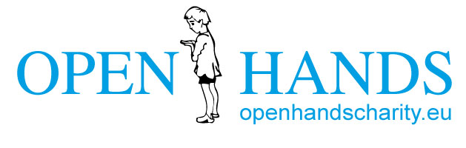

Open Hands Report Humanity at Heart
September 2020

About Open Hands
We work among the most vulnerable and disadvantaged children in Romania and our programs transform lives. We currently care for over 100 children and their families in two locations, Gheorgheni and Suceava area. Our work focuses on supporting children at home, at school and at the Rainbow House.
Rainbow House (RH)

The RH provides day care for up to 25 children a week and has now been open for over 4 years. We continue to notice profound changes in the children’s lives under the careful and loving guidance of Olga Kalusi (the RH manager) and Ramona Fulop (her support worker). Since most of the children are ethnically Roma, the most discriminated ethnic minority group in Europe, we decided that it would be best for the children if we employed Roma staff. Both Olga and Ramona are Roma and this helps us to get a better cultural understanding of children and their families and ensures that no child is discriminated against on grounds of ethnicity.
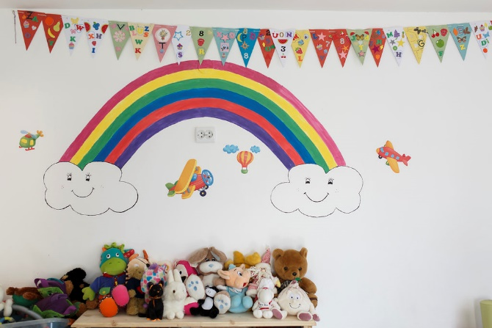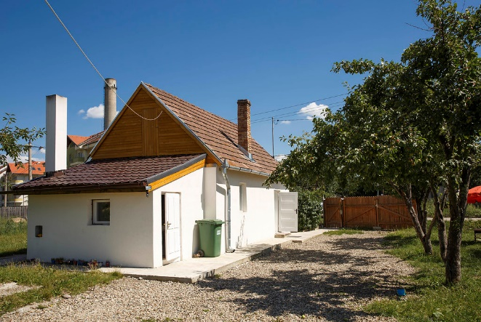
Education
During the past years we have seen a steady, positive improvement in children’s educational achievements with all RH children enrolled and regularly attending school. Ms Kalusi keeps in touch with schools to ensure that children attend regularly and any issues are seen to and addressed. Children learn and do their homework at the RH.
We have enrolled all younger children at the local kindergarten, the children also attend the RH where they learn through play. We have found that kindergarten attendance hugely benefits the children’s further learning at primary school.
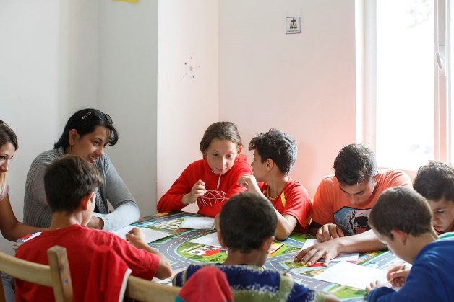
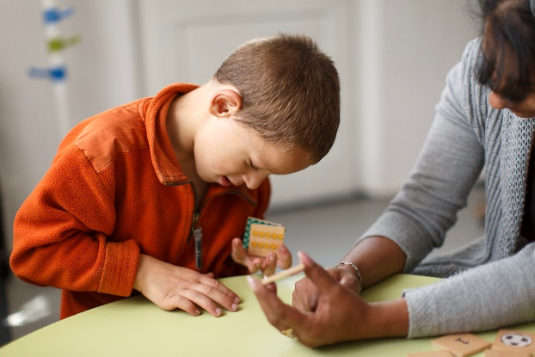
Case Study
We have found that children feel emotionally safe at the RH and are able to share their feelings in small groups. I would like to mention the exceptional change of two siblings who have come from a particular difficult home. Both children had been homeless in the past and their mother’s parenting capacity was lacking emotional warmth, stability, safety and basic care. When the children first began coming to the RH they had experienced many traumatic situations and were scared and withdrawn. Through the loving care of Ms Kalusi and Mrs Fulop the children began to feel safe at the RH. The changes that the RH brought to their lives became very visible. The children began to smile, laugh, talk and play freely. By working not only with the children but also showing their mother unconditional positive regard, we were able to work with her and build a relationship of trust and respect. We were able to move the family into safe accommodation. The relationship between the children and their mother rapidly changed with the mother’s parenting abilities immensely improving, to the point were the children feel safe and close to their mother at home. Both children continue to come to the RH and we also support the family at home.
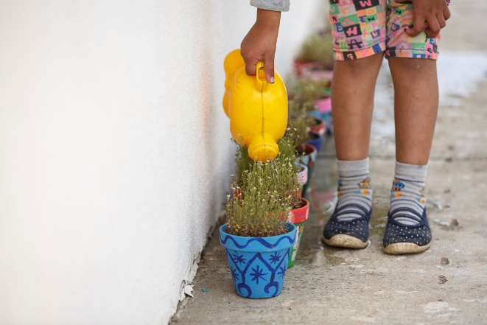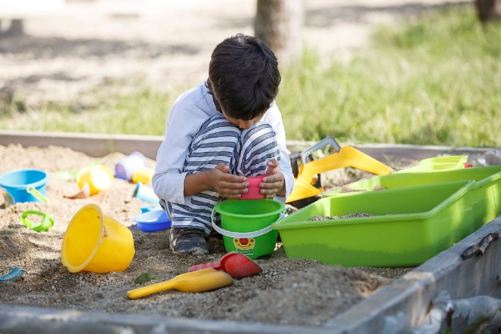
New Space
In April 2019 a generous donation allowed us to buy a new, 13m long portable cabin which sits on a new concrete base next to the RH. It serves as a much-needed office for Ms Kalusi and provides additional storage space for clothing, furniture and other donated items that are of great benefit to the children and families.
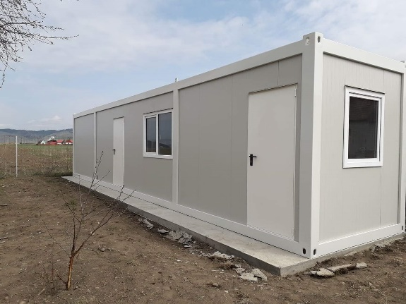
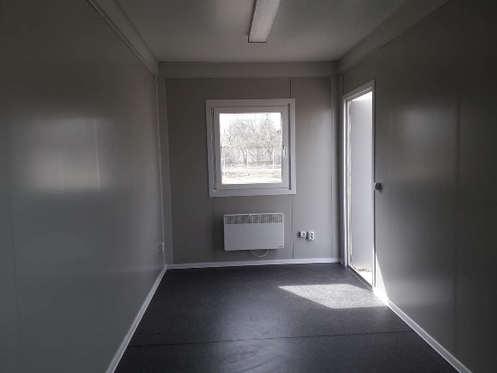

New car
Another positive development is that we have been able to replace the Suceava 4x4 and so move the old one to Gheorgheni. This has allowed Olga to provide transport to the RH for the children instead of them having to walk several kilometres or get a bus, which they can ill afford.
Aid transports
With the help of partner organisations from Germany, lorry loads of donated clothes, shoes, toys, furniture and other useful items have been successfully transported to the RH in Gheorgheni. These items are a great help to our families, especially as winter approaches.
Covid 19 Response

This became a concern for us towards the end of February this year and is ongoing at the time of writing this report. Our response so far has been as follows:

- To close the RH, give it a deep clean and re-paint the rooms (see above)
- To suspend the ASP and the work in Timpoceni.
- To find creative ways to continue to communicate with and to support our families and children during this challenging time.
- To provide families in April and May with twice as much food, washing powder and hygiene articles as would be normal.
- To provide clothing and shoes for the children
- Working with teachers, to deliver and collect home-work folders so that the children’s education is disrupted as little as possible.
- To require our staff to take necessary precautions by social distancing, wearing protective masks and gloves and keeping in line with government guidelines

Although we have lost a handful of regular individual donors and some of our organisational donors have their own problems, we are thankful that so far, our finances are holding up and we can meet immediate needs. As the economic fallout of Covid 19 becomes more apparent, things may become more difficult financially.

RH and Covid 19

Although at the time there were no reported cases of Covid 19 in Gheorgheni, the RH had to close in March 2020 in line with government regulations. However, since the closure there have been reported cases of Covid 19 in Gheorgheni and the population got very worried. We are not aware of any Covid 19 infections amongst any RH children’s families. However, the families’ living conditions are such that they are always at greater risk of illness of various kinds.

During the strict lock down period, the RH children and families living in the Roma slum were only allowed to leave and go to the supermarkets once a week. It was a very isolating time for the families but we managed to keep contact and brought food supplies and help to the children. Olga Kalusi stayed in close contact with the families during this period. The RH staff also cleaned and refreshed the RH.

Over the summer Olga has been busy preparing the children for the re-opening of schools and kindergarten on September 14th. We would like to let the children settle in at schools and kindergartens for the first two weeks and are planning on re-opening the RH at the beginning of October again. To do this we need to follow governments strict Health and Safety guidelines.

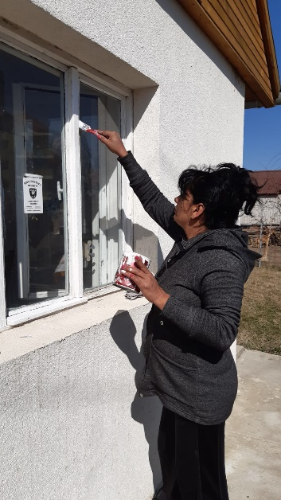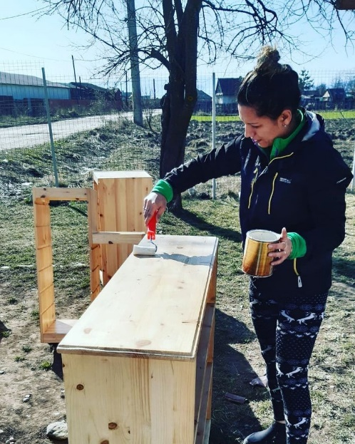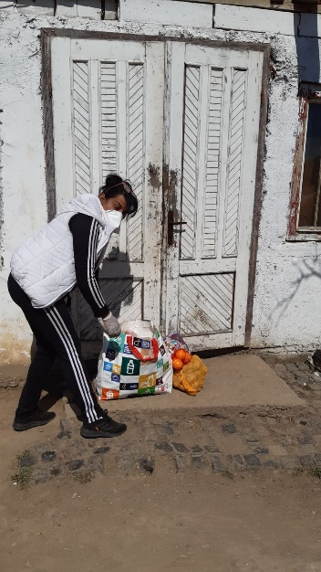

Family Outreach
Open Hands remains committed to working more widely among vulnerable and neglected children and their families in the Suceava and Gheorgheni areas. The outreach program continues to grow with new families joining. Open Hands now regularly helps over 100 children through this program, which focuses on education and the things that support it such as home visits, nutrition, health and housing.

This aspect of our work also encompasses our After-school Program (ASP), which gives children space to do their homework and other activities in a quiet and disciplined environment without the distractions they would encounter in their homes, and celebrating birthdays, which marks each child’s birthday with a cake and present – something which would not happen if Open Hands did not do this.

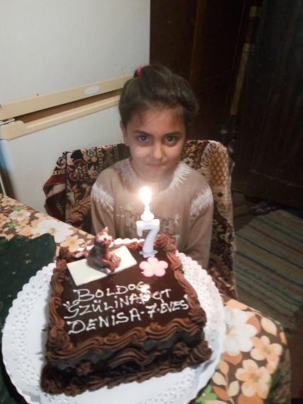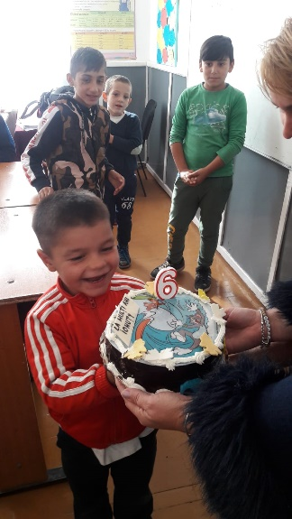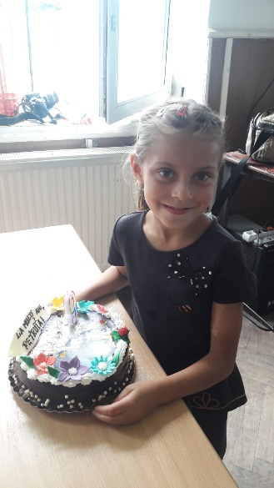

Through intensive support both at home and at school the lives of the children and their families are improving. The nature of the support we offer varies with the needs of each family. In some cases, we can reduce support after 2-3 years because the family has shown itself better able to cope at home; we continue to work with the children at school but reduce the frequency of the home visits. Other families need longer to find a way out of poverty.

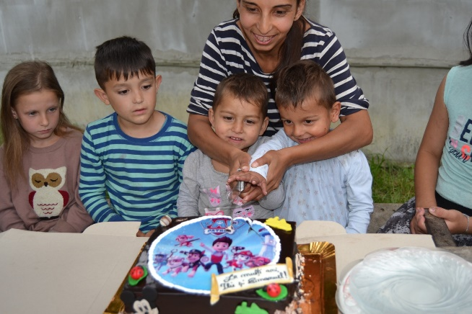
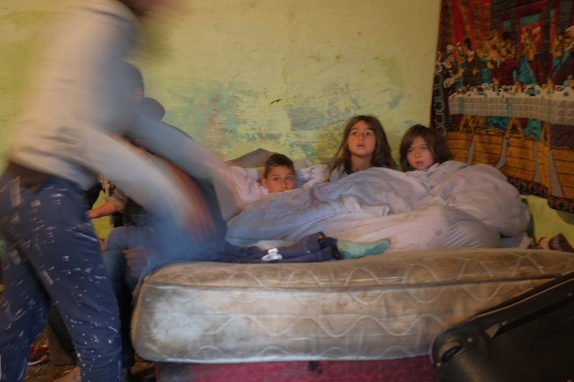

Housing

During this year we continued to improve and renovate homes of disadvantaged families. As an example, we have been able to build a new house for the family of Malina - a 13-year-old girl who lives with her mother suffering from metabolic syndrome and learning disabilities and her elderly grandmother. The three of them live in one tiny old room where they cook, live and sleep. The condition of the room is life-threatening because the ceiling is so dilapidated and saturated that it can collapse at any time. Partnering with the local mayor we began building a new house for the family. The building work is almost complete now and the new home should be ready for the family to move in during the autumn.

Over the years, Malina has made steady progress at school but the difficult housing situation put huge a strain on her ability to maintain this. Soon for the first time in Malina’s life she will live in a proper house with more space as well as running water and a bathroom.

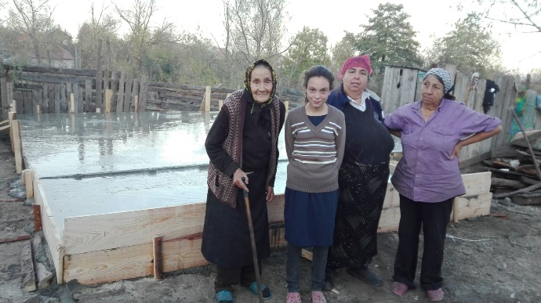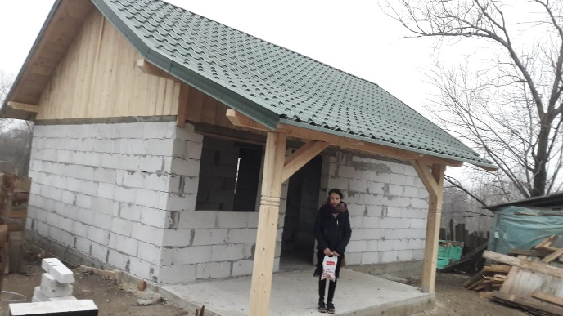

Lighthouse Project

In important validation of the Open Hands approach, we have been asked by a local authority in another part of Suceava county to partner with them on a new project in a very impoverished rural community called Timpoceni.

Our work started in November. We estimate that around 419 people, of which 206 are children, live isolated and forgotten at the margins of society. Alcoholism, violence, poverty and failure to attend school are common. Waste is not collected but scattered everywhere. Since there is no sanitary system and no source of clean drinking water, people are prone to diseases. Empty promises, lack of work and of any noticeable change to their situation has left them in a state of desperation and depression.

We are working on the school attendance of children. Our Romanian staff member, Firuta Pastrav, is in regular contact with parents, teachers and the local authority with the aim to involve the entire community to bring positive change.

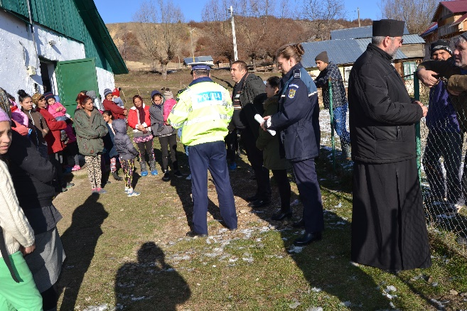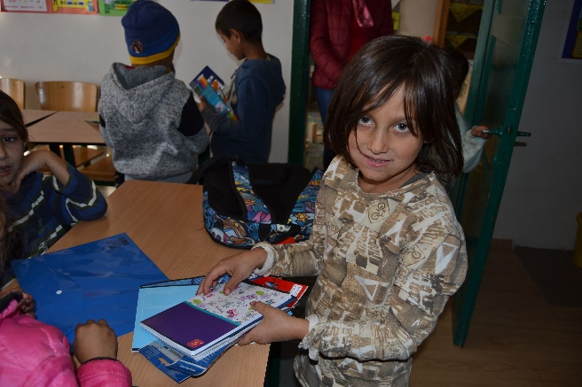

Thank you

I would like to thank everyone at Humanity at Heart for the wonderful support you are giving to the Rainbow House children. Thank you for all the hard work, love and dedication which you put into running the shop which enables us to brighten the lives of these children and families.

